Information Management

Group Assignment

**Final Report**

Part 2

**The National Library of Ireland**



**Group 24**

Sharon Olorunniwo

Jack Donal Collins

Colman Kinane

Tom Wiśniowski

Fintan Gibney

National Library of Ireland

CS2041 - Information Management - Group 24

Final Report

Introduction 3

Project Contributions 3

XML Project Contributions 3

UML Project Contributions 3

Our Background Research & How We Collected it 4

Undertaking the Task 5

UML Case Diagram 6

UML Use Case Diagram Scenarios 7

UML Class Diagram 14

UML Class Diagram Description 15

UML Activity Diagram – “*Request Consultation”* 17

UML Activity Diagram – “*Host Consultation”* 18

Ethics Canvas 19

Description of Ethics Canvas 20

Strengths & Weaknesses of UML Design 22

UML Case Diagram 22

UML Class Diagram 22

UML Activity Diagram 23

UML Case Diagram 23

Changes Made to UML Design 24

Strengths & Weaknesses of XML Design 24

XML & XQuery Design 24

XML Implementation 26

*material.xml* 26

materialrequest.xml 32

material_order.xml 34

readerticket.xml 36

location_booking.xml 39

librarians.xml 40

consultation_booking.xml 42

XQuery Implementation 44

# Introduction

The National Library of Ireland is Ireland’s National Library and is under the remit of the Minister for Arts, Heritage and the Gaeltacht. The National Library provides a multitude of services to not only the Citizens of Ireland but to people from all over the world. The National Archives contain genealogy records dating back prior to the creation of the state.

Our Report aims to model the system used by the national Library and demonstrate the multiple actors that affect the day to day operations of the National Library.

# Project Contributions

## XML Project Contributions

**XML Design** – Jack Donal Collins & Colman Kinane

**XQuery Code** – Sharron Olorunniwo & Jack Donal Collins

**XQuery Explanations** - Sharron Olorunniwo

**XML Comments & Changes to UML** – Colman Kinane & Jack Donal Collins

## UML Project Contributions

**Introduction & Background Research** – Jack Donal Collins & Tom Wiśniowski

**UML Case Diagram** – Whole Group Contributed

**UML Case Diagram** Scenario Descriptions – Sharon Olorunniwo

**UML Class Diagram** - Whole Group Contributed

**UML Class Diagram Description** - Sharon Olorunniwo

**UML Activity Diagrams & Descriptions** – Colman Kinane

**Ethics Canvas & Ethics Canvas Description** – Jack Donal Collins

**UML Strengths & Weaknesses of Design** – Colman Kinane, Jack Donal Collins & Sharon Olorunniwo

# Our Background Research & How We Collected it

Our Background research focused on what the National Library actually does and more importantly how it does it. We used the National Library Website & Other Government resources extensively to conduct our research.

One of the first questions we asked ourselves was *“so what does the National Library actually do?*” When we think about any library, the first thing in our heads is “renting out books”. The National Library is actually completely different. The primary focus is to gather all material which relates to Ireland and its history and preserve it for future generations. Even if no one visited, the library would continue to collect and store all this information.

There are 5 main things that the National Library does in order to carry out its mission which is determined by Legislation under the authority of the office of the Minister for Arts, Heritage and an Gaeltacht.

1. The primary aims is to collect library materials, relating to Ireland and to provide an accurate record of Ireland's output in manuscript, print and other media for present and future users.
2. Holds the most comprehensive collection of Irish documentary material in the world. They subsequently store the materials and allow the general public to access the materials.
3. Organizes exhibitions, public lectures, and other events involving:  poetry, music, theatre, children's storytelling, creative workshops, and others.
4. Providing a wide range of services for primary, post-primary, third level students, lifelong learners and educators.
5. Provides Genealogy Advisory Service for those beginning family history research.

So how does the Library gather all this material? There are three main ways;

1. **Legal Deposit** - most publishers in are obliged to deposit copies of their publications.
2. **Donation**- Generous individuals may endow a collection to the state or make a donation while they are alive.

1. **Purchase** - Everything which the library sees as valuable source of information, and which they couldn't attain through Legal Deposit is bought in the interest of the state.

Probably the most important thing about the National Library is that it is a closed stack reference library which means that books and other items can’t be taken out and must be ordered for consultation in reading rooms. To actually view material, you need a Reader's Ticket, which you can get only if you're aged 16 years or older and which is valid for a maximum of 3 years. You can then order the material you wish to view, either online or in person, and when it's available you can come in to see it, sometimes you will be designated a certain day and in many occasions, you will be allocated to a particular room to view it in.

# Undertaking the Task

We decided to model how material is requested and accessed by Patrons. The reasons for this was because it was the most intricate system and would allow us to demonstrate to a high level how much goes on behind the scenes of a such a complex organisation. There are three methods of booking a viewing of a material;

1. Online,
2. Telephone,
3. In person.

We will tackle the problem by researching the libraries processes and by mapping the online method of booking a viewing for a material held by the library through the use of UML use case diagrams and UML class diagrams.

# ../Downloads/Use%20Case%20Diagram.pngUML Case Diagram

# UML Use Case Diagram Scenarios

**Requesting a material to view**

**Primary actor(s):**   Patron

                             National Library Login System

  Material Database

Librarian

**Precondition(s):** Valid Reading Ticket

Material is available

Space available in Reading Room

**Normal Scenario:**

1. Patron logs onto the NLI online order system
2. The patron enters their desired material type to view
3. Search material call(ID) number in NLI Catalogue in order to complete the first section of the online order form
4. The patron enters the material Author and Title
5. The patron enters Reading Ticket number to validate their ticket
6. The patrons order is then submitted to the National Library Ireland
7. The material database is then updated
8. The patron arrives at the library desk
9. The librarian validates the patrons Reader Ticket
10. The librarian gives the patron their ordered material
11. The Librarian then assigns the Patron to a Reading Room
12. The Patron completes use of material
13. The Patron returns the material to the librarian
14. The librarian places the material back on the stack
15. The Material Database is then updated

**Special Scenario:**

1. Patron has the option of booking a genealogy consultation
2. The patron requests a consultation at the librarian desk
3. The Librarian checks the availability of a consultation session
4. If there is a slot available the Librarian hosts a consultation session for the Patron

**Error Scenario:**

* 1. **Invalid Reading Ticket**

1. Patron enters the material information in the online application
2. The Patron enters their Reading Ticket number
3. The Patrons Reading Ticket comes back as Invalid
4. The Patron renews their Reading Ticket in person at the National Library
5. **No Reading Ticket**
6. Patron enters the material information in the online application
7. If the Patron does not have a Reading Ticket they fill out the online application after entering the material information
8. **Material is not available/Access Denied**
9. Patron enters the material information in the online order application
10. If the requested material is not available the Patron receives an error message
11. The Patron then has the choice to be put on a waiting list for the requested material
12. **No Reading Spaces available**
13. Patron enters the material information in the online order application
14. If the Reading space is not available the Patron receives an error message
15. The Patron then has the choice to be postpone their viewing to a later date
16. **Library Material Not Returned**
    * 1. Librarian checks list of Materials not returned at the close of business.
      2. Librarian Checks to see if the material has been left at an alternative location, if not he/she will contact the patron to request information about the material.

**Apply for a Reader's Ticket**

**Primary actor(s):**   Patron

                             National Library Login System

**Precondition(s):** Photographic ID

Must be over the age of 16

**Normal Scenario:**

1. Patron goes to the National Library Main building
2. Patron approaches a librarian to request a reading ticket
3. The librarian then checks that the patron has valid photographic identification and is older than the age of 16
4. The patron must then fill out an online application
5. The patron must wait a few minutes for their card to be processed.

**Error Scenario:**

* 1. **Patron has to renew there card**

1. Patron enters the National Library Reading Ticket Office
2. The Patron presents their most recent reading ticket to the librarian
3. The librarian validates the ticket.
4. If the reading ticket has been out of date for over 12 months then the patron must present some form of photographic IS.
5. Once the patron has been validated a new Reading Ticket is issued.
6. **The patron does not have valid ID**
7. Patron enters the National Library Reading Ticket Office
8. The patron requestS for a Reading Ticket
9. The patron fails to present a suitable form of photographic ID
10. The patron is refused a Reading Ticket until a suitable form of identification is presented.
11. **The patron has lost their ticket**
12. If the patron has lost or misplaced their ticket they must apply for a new one
13. Patron goes to the National Library Main building
14. Patron approaches a librarian to request a reading ticket
15. The librarian then checks that the patron has valid photographic identification and is older than the age of 16
16. The patron must then fill out an online application
17. The patron must wait a few minutes for their card to be processed.

**Request a Consultation**

**Primary actor(s):** Patron

                             National Library Login System

Librarian

**Precondition(s):** Valid Reading Ticket

An available consultation room

An available librarian

**Normal Scenario:**

1. Patron logs onto to the online system
2. The Patron requests a consultation
3. The librarian the checks if there is a consultation room and librarian available.
4. Once the location and the librarian are confirmed the booking can be finalized.
5. The patron then comes into the library and attends the appointment

**Error Scenario:**

1. **No room available**
2. If there are no rooms available the patron has the option of posting their appointment or cancelling their appointment.
3. **No librarian available**
4. If there are no rooms available the patron has the option of posting their appointment or cancelling their appointment.

**Authenticate Readers Ticket**

**Primary actor(s):**   Patron

                             National Library Login System

**Precondition(s):** Reading Ticket

A working electronic device

**Normal Scenario:**

1. The Patron logs onto the online system
2. They search and enter the details of the material they would like to view
3. They then move onto entering their reader card details.
4. If the ticket is valid the material request order goes through successfully

**Error Scenario:**

1. **No room available**
2. The Patron must apply for a new Readers Ticket

**Search Material Database**

**Primary actor(s):**   Patron

                             National Library Login System

  Material Database

**Precondition(s):** A working electronic device

**Normal Scenario:**

1. Patron logs onto the NLI online order system
2. The patron enters their desired material type to view
3. Search material call(ID) number in NLI Catalogue in order to complete the first section of the online order form
4. The patron enters the material Author and Title
5. The patron then navigates to the following website: <http://catalogue.nli.ie/>
6. The patron then searches other additional information on their requested material.

**Error Scenario:**

* 1. **Invalid Reading Ticket**

1. Patron enters the material information in the online application
2. The Patron enters their Reading Ticket number
3. The Patrons Reading Ticket comes back as Invalid
4. The Patron renews their Reading Ticket in person at the National Library
5. **No Reading Ticket**
6. Patron enters the material information in the online application
7. If the Patron does not have a Reading Ticket they fill out the online application after entering the material information
8. **Material is not available/Access Denied**
9. Patron enters the material information in the online order application
10. If the requested material is not available the Patron receives an error message
11. The Patron then has the choice to be put on a waiting list for the requested material

**Deliver material**

**Primary actor(s):**   Patron

  Material Database

Librarian

**Precondition(s):** Viewed Material

**Normal Scenario:**

1. The patrons order is then submitted to the National Library Ireland
2. The material database is then updated
3. The patron arrives at the library desk
4. The librarian validates the patrons Reader Ticket
5. The librarian gives the patron their ordered material

**Update Material Status**

**Primary actor(s):**   Patron

                             National Library Login System

  Material Database

**Precondition(s):** Valid Reading Ticket

Material is available

**Normal Scenario:**

1. Patron logs onto the NLI online order system
2. The patron enters their desired material type to view
3. Search material call(ID) number in NLI Catalogue in order to complete the first section of the online order form
4. The patron enters the material Author and Title
5. The patron enters Reading Ticket number to validate their ticket
6. The patrons order is then submitted to the National Library Ireland
7. The material database is then updated
8. The patron arrives at the library desk
9. The Patron completes use of material
10. The Patron returns the material to the librarian
11. The librarian places the material back on the stack
12. The Material Database is then updated

**Return material to stack**

**Primary actor(s):**   Material Database

Librarian

**Precondition(s):** Material

**Normal Scenario:**

1. The Patron completes use of material
2. The Patron returns the material to the librarian
3. The librarian places the material back on the stack
4. The Material Database is then updated

# https://lh5.googleusercontent.com/orjUEp2vbhAQQxj5icAeWZ3foKg7_jILb4jQV4xuW9RHuvT7icNRn8X_B3ceJvuM5QydUn0uGisNrfhGIPXVA84_A-lwew95B-nAJ9lcVSNhef3UxBpDFUJwUhwG0Bb-16_IQ-S7P89CdQUML Class Diagram

# UML Class Diagram Description

The National Library model describes the main classes and relationships which could be used during the analysis phase to better understand the National Library’s Management System.

Every library has the following attributes: Address, Establishment Date, Name etc, all of which are in our library class. The library employs more than one librarian and the librarian works for one library, hence the cardinality of one to more than one. There is a composition between the library and the librarian because you cannot have a librarian without a library.

In order to place an order request to view a material in the National Library, a valid Reading Ticket is a requirement, hence we have a composition between the Reading Ticket and Material Request class. The Reader Ticket is only created for one Library and the National Library has multiple Readers Tickets on record for their multiple visitors. Therefore the cardinality between the Reader Ticket and the library is 1 and 0..* For every Patron there is one Reader Ticket. In order to apply for a Reader's Ticket the Patron must supply the following information: Date of Birth, Name, Photographic ID, address. The following attributes are included in the Reader Ticket class, only the Name, Photo, Date of Birth are the pieces of information that is public in the Reader's Ticket class the other attributes have restricted visibility. The Reader's Ticket has a issue and expiry date. The cardinality between the Reading Ticket and Material Request classes is between 0...3, this is because a Patron can only order up to 3 items to view at a time.

Without a material request there would be no reason to book a reading room hence the composition between the material request class and the Reading_Room Booking class.

When a material order request is processed and approved the material database is updated. In the National Library the materials are separated into seven categories: Maps, Newspaper, Book, Journal, Newspaper, Manuscript and Musical Score. For this reason we decided to use subclasses instead of aggregation relationships. This was because we felt subclasses were more appropriate and made sense in regards to material organization in the database and library. The material category subclasses inherit from the material class. Regardless of type, every single item in the National Library available for viewing in the National Library has the following attributes: ItemID, ItemName, ItemDescription, ItemPermissionLevel, ItemSource. The database class must be able to notify the librarian and patron if a particular material is unavailable for a viewing. Once the order has been assigned and confirmed the librarian allocates a reading room to the patron. The cardinality between Room_Booking class and Reading Room location class is one and one because every Reading_Room booking only books one location.

The library also offers consultation on genealogy records for patrons who request it. The Consultation_Booking class requests availability of a library consultant to host the viewing for the patron. The Library_Consultant confirms the consultation availability. The cardinality between the Consultation_Booking class and Library_Consultant class is one and one. There is a composition relationship between the Consultation_Booking class and Consultation class, without a consultation booking there is no consultation session.

# UML Activity Diagram – “*Request Consultation”*

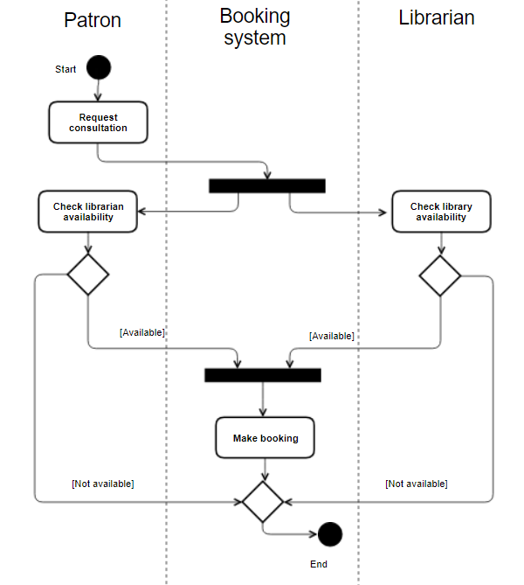

Description

The request consultation is a meeting between a patron of the library and a librarian about genealogy. The process starts with the patron requesting the consultation. The request triggers the system to check the availability of the librarian and for space in the library. These checks return either a negative or positive result. If both checks come back positively then the booking is made. If either is negative the booking cannot be made.

# UML Activity Diagram – “*Host Consultation”*

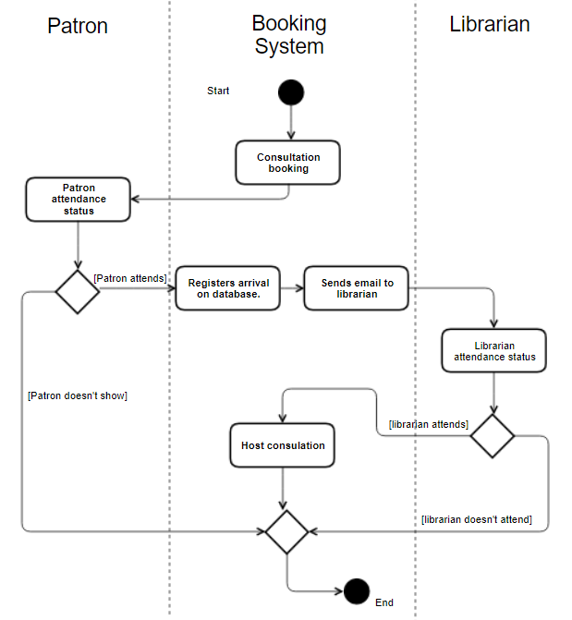

Description

Assuming that the consultation has been created in the system and scheduled correctly. When the patron arrives, they can go to the desk and make the librarian on duty aware of their appointment, the booking system will email the librarian scheduled to meet with the patron that they have arrived, It can also allow the librarian to cancel the meeting if an unscheduled conflict has arisen.

# ../../../../../Desktop/Screen%20Shot%202017-11-12%20at%2016.21.05Ethics Canvas

# Description of Ethics Canvas

In General Terms Libraries tend to be seen as quite ethical organisations who merely persevere data in so far as they can, so as to be a reference for current and future generations. With respect to the National Library, decisions about what kind of data (Census, Genealogy records & Legal Deposit Laws) are principally decided by the state and the Library has no legal influence over it.

One of the biggest challenges facing the National Library and particularly the state, is the storage of digital content. This type of content is often edited without the original data being preserved. For example, if the state updated a website it might not make a previous version of the site available online.

**Additional Explanations of Ideas**

**Individuals & Groups Affected**

The Library has many stakeholders, ranging from a University Academic to Book & Material publishers. Publishers have to manage their legal responsibility to the Library while Academics are the most common users of the Library facility.

**Behaviour**

Historically the Library has been able to store all major documents of historical importance. However, with the advent of the internet, over the next few years the library will have to look at becoming a permanent digital store of Information. Storing copies of webpages which are of importance to the state. Legal Deposits may also be extended to E-Books.

**Relations**

The relationship the National Library has with the people of Ireland is incredibly important, It allows people to find out more about their past, learn more about Irish history or what the opinions of the people of Ireland were at certain points in our history.

**Worldviews**

The Library has a legal and moral obligation to remain apolitical and to record and maintain a record of all publications regardless of their nature. It is incredibly important that the library retains the highest level of ethics when it comes to maintaining and recording documents which could be seen as distasteful by the majority of the population. For example, In Germany’s case it is incredibly important they maintain Nazi propaganda documents, even though such documents don’t represent the beliefs of the people they still form an integral part of that nation’s history.

**Problematic Use of Resources**

It is often the case in science and in history that facts that were once thought to be true are no longer so. It would be problematic and impossible for a Library to keep a record of all cases where material in its archive has been disproven as it is the library’s responsibility to simply maintain a record and not ensure accuracy.

**Product or Service Failure**

If proper records of materials being intrusted to the national Library are not kept it is possible that materials could be lost, stolen or simply forgotten about.

**Uncategorised Ideas**

As the National Library is a public institution they must comply with the Ethics in Public Office Act. This act ensures they behave in a proper manor and prevents political decisions being made within the national Library,

**Thoughts on the Ethics Canvas**

Overall, we felt the ethics canvas achieved its goal of forcing us, the designers of an information system to question and evaluate what we were planning on implementing but more importantly how we planned on doing so.

We think the ethics canvas works well, however we felt the ethics canvas focusses to much on the negative effects of implementation and does not do enough to show how the negatives of an implementation could be outweighed by the positives of implementing a project or change.

# Strengths & Weaknesses of UML Design

## UML Case Diagram

**Strengths**

Our use case diagram clearly shows the process of using the online booking system of the National library. It is clearly laid out and is intuitive and gives a clear view of the interactions of the various actors amongst each other and also with the system as a whole.

We believed our UML Case Diagram should be more or less the blueprint for the UML Class Diagram. This influenced the choices made in the design process. It was vital the it accurately reflected the overall function of the system.

**Weaknesses**

The weakness of this UML case diagram is that it doesn’t show the range of bookings and services provided by the library. It is a very basic version of the library’s management system. For example, it does not address the fact that the library patron has the option to view a multitude of different materials of different types.

The reason we decided to design a simplified Use Case Diagram, was to allow us to demonstrate the key fundamental processes of the library’s management system without going into all the intricacies of the entire booking system process.

## UML Class Diagram

**Strengths**

The class diagram gives a much more detailed description of the operations within the library.

Our UML Class Diagram makes good use of inheritance which is evident in our overall design. The National Library has different types of materials available for viewing, so we initially created separate classes for each material type. We quickly realised that these classes possessed similar attributes so we took this as an opportunity to make good use of inheritance and created a main Material class with the different types as subclasses. By doing this we were able to display more clearly the entire operation whilst maintaining the complexity of the system.

**Weaknesses**

Perhaps the biggest weakness of our class diagram is its readability. We found it difficult to find a good balance between displaying as much information as we could and also making it easy to interpret. I could definitely see people with no prior knowledge of UML having great difficulty interpreting the diagram. But the detail in the diagram is admirable and well laid out given the exorbitant amount of information within said diagram.

## UML Activity Diagram

**Strengths**

The strengths of the UML activity diagram is similar to the Use case diagram is it's easy to read nature. They are well labelled and the process is fairly intuitive. It gives a clear and whole view of the process of ‘booking a consultation’. Makes use of the joins and forks operations which make the flow of the activity clearer to a reader. Our diagram makes use of swim lanes which give a clearer view of which objects are responsible for which internal activity.

**Weaknesses**

A weakness of our UML activity diagram is that the activities chosen and the selection of activities there was to choose from were quite narrow. We, as a collective, felt that the activities were already narrowed down significantly in our UML use case diagram. There was not proverbial meat on the bones left on the activities to make a nice extensive UML activity diagram

## UML Case Diagram

**Strengths**

In Summary, Our Design shows the operations of the National Library in a detailed fashion. We believe our design is accurate in the way it displays how each actor interacts with the system.  Gave a nice step by step view of the array of activities and classes that we looked at. We believe our UML Class Diagram is detailed and could easily be transferred into XML for the second part of the project. When we started out we set out to complete the entire project with the end goal in sight so as to ensure our XML implementation could be easy to understand and more importantly easier to implement.

**Weaknesses**

A weakness of our overall design is that it looks at a rather narrow scope of the library. Perhaps a criticism of our design is that it doesn’t deal with the processes of cataloguing and such other library activities. The reason for this was that there was very little information on the cataloguing process that was readily available. There is a limited amount of information given by the NL.

# Changes Made to UML Design

One of the key advantages of our design was that from the start of the project we wanted to ensure that everything we designed could be easily and effectively implemented into XML with an appropriate schema.

We were very happy with our implementation of our UML Class Diagram into XML. We did make minor adjustments such as changing of some naming conventions and the addition of some information into our XML classes. The only large-scale change was the removal of the permission level class which was instead substituted as a single attribute of the material class, we felt the additional information the permission class was providing was superfluous

# Strengths & Weaknesses of XML Design

## XML & XQuery Design

**Strengths**

The strength of our xml design is based around the use of id numbers for every xml class. This allows us to clearly see which entry in the respective xml classes the other classes are referring to. It allowed us to follow the various processes such as orders and consultations all the way through with ease. The xml makes use of a clear, well documented DTD which is laid out in the same manner in each class allowing for them to be easily understood. We have multiple entries for each xml class which allows us to run multiple Queries and test a range of the information. For example, we made a reader's ticket that was out of date so that we could run a very important real life application of the reader tickets; to check its validity. Each of our entries provides a lot of information about that individual entry and they vary enough so that they would not be easily mixed up with each other. Our use of cardinalities provides even more information about the various elements and arises from our UML class diagram. It is important to have a clear class diagram to base the xml off. In terms of our queries, we feel we implemented these quite well, we made good use of built in functions.

**Weaknesses**

One of the weaknesses of our xml design is that it doesn't cover every aspect of our UML use case design. It doesn’t map the whole system and therefore it may be harder to understand for a person outside the project to understand. Our ID numbers are all very similar which may be a source of confusion for readers.

For some attributes that use entities the list of possible entities of the attribute is quite long. Perhaps it may have been more efficient for it to have been left as an element and #PCDATA. In Terms of our XQueries, we tried to implement these in a way that a good User Interface would be able to interpret and use well. However it is possible at times that the information being returned could be slightly irellevant and that a simple single return value would be more useful than a multi value return.

# XML Implementation

## *material.xml*

<?xml version="1.0" standalone="yes" ?>

<!--Start DOC TYPE DECLARATION-->

<!DOCTYPE materials [

<!ELEMENT materials (material*)>

<!--the material ID allows us to refer to a material very easily in outside xml classes-->

<!ATTLIST material id CDATA #REQUIRED>

<!--Permission level of a reader required to view this material-->

<!ATTLIST material permLevel CDATA #REQUIRED>

<!--The various mediums of material available in the library-->

<!ENTITY BOOK "BOOK">

<!ENTITY NEWSPAPER "NEWSPAPER">

<!ENTITY MAP "MAP">

<!ENTITY JOURNAL "JOURNAL">

<!ENTITY MUSIC "MUSIC">

<!ENTITY MANUSCRIPT "MANUSCRIPT">

<!ATTLIST material type  (BOOK | NEWSPAPER | MAP | JOURNAL | MANUSCRIPT | MUSIC ) #REQUIRED>

<!--The status of the material at a point in time-->

<!ENTITY IN_USE "IN_USE">

<!ENTITY RETURNED "RETURNED">

<!ENTITY BOOKED "BOOKED">

<!--A list of elements that describes all material-->

<!ELEMENT material (material.itemName,material.description,material.addInformation, material.itemSource,material.itemAvailable,material.orderHistory*,map?,newspaper?,book?, journal?, newspaper?,manuscript?,musicalscore?)>

<!ELEMENT material.itemName   (#PCDATA)>

<!ELEMENT material.description   (#PCDATA)>

<!ELEMENT material.addInformation  (#PCDATA)>

<!ELEMENT material.itemSource  (#PCDATA)>

<!ELEMENT material.itemAvailable  (#PCDATA)>

<!ELEMENT material.orderHistory  (material.orderHistory.order*)>

<!ATTLIST material.orderHistory.order id CDATA #REQUIRED>

<!ELEMENT material.orderHistory.order (#PCDATA| BOOKED | IN_USE | RETURNED)*>

<!--close the DOCTYPE declaration-->

<!--More specific elements and attributes particular to a certain type of material eg cartographer for a map and editor for a newspaper-->

<!--Map-->

<!ELEMENT map  (map.cartographer,map.organisation)>

<!ATTLIST map mapArea CDATA #REQUIRED>

<!ATTLIST map originDate CDATA #REQUIRED>

<!ELEMENT map.cartographer  (#PCDATA)>

<!ELEMENT map.organisation  (#PCDATA)>

<!--Newspaper-->

<!ELEMENT newspaper (newspaper.editor,newspaper.publisher,newspaper.title)>

<!ATTLIST newspaper pubDate CDATA #REQUIRED>

<!ATTLIST newspaper lang CDATA #REQUIRED>

<!ATTLIST newspaper edition CDATA #REQUIRED>

<!ELEMENT newspaper.editor  (#PCDATA)>

<!ELEMENT newspaper.publisher  (#PCDATA)>

<!ELEMENT newspaper.title  (#PCDATA)>

<!--Book-->

<!ATTLIST book ISBN CDATA #REQUIRED>

<!ATTLIST book genre CDATA #REQUIRED>

<!ATTLIST book lang CDATA #REQUIRED>

<!ELEMENT book  (book.author,book.title)>

<!ELEMENT book.author  (#PCDATA)>

<!ELEMENT book.title  (#PCDATA)>

<!--Journal-->

<!ELEMENT journal  (journal.title,journal.editor,journal.article*,journal.dateOfPublication)>

<!ATTLIST journal lang CDATA #REQUIRED>

<!ATTLIST journal vol CDATA #REQUIRED>

<!ELEMENT journal.title  (#PCDATA)>

<!ELEMENT journal.editor  (#PCDATA)>

<!ELEMENT journal.article  (#PCDATA)>

<!ELEMENT journal.dateOfPublication  (#PCDATA)>

<!--Manuscript-->

<!ELEMENT manuscript  (manuscript.origin,manuscript.status,manuscript.title)>

<!ATTLIST manuscript lang CDATA #REQUIRED>

<!ELEMENT manuscript.origin  (#PCDATA)>

<!ELEMENT manuscript.title  (#PCDATA)>

<!ELEMENT manuscript.status  (#PCDATA)>

<!--Musical Score-->

<!ELEMENT musicalscore  (musicalscore.title,musicalscore.organisation)>

<!ATTLIST musicalscore composer CDATA #REQUIRED>

<!ATTLIST musicalscore compositionDate CDATA #REQUIRED>

<!ELEMENT musicalscore.title  (#PCDATA)>

<!ELEMENT musicalscore.organisation  (#PCDATA)>

]>

<materials>

<material id="002" type ="&BOOK;" permLevel="1">

<material.itemName>Colman's Book</material.itemName>

<material.description>A Book By Colman</material.description>

<material.addInformation>Somewhere in a galaxy far far away</material.addInformation>

<material.itemSource>Donation by the Kinanes"</material.itemSource>

<material.itemAvailable>false</material.itemAvailable>

<material.orderHistory>

<material.orderHistory.order id="001">&BOOKED;</material.orderHistory.order>

</material.orderHistory>

<book ISBN ="9928957895752" genre="horror" lang="eng">

<book.author>Colman Kinane</book.author>

<book.title>The Adventures of Colman : The last Dorito Lover</book.title>

</book>

</material>

<material id="003" type ="&BOOK;" permLevel="2">

<material.itemName>Book A</material.itemName>

<material.description>Magic Mike</material.description>

<material.addInformation>Some Desc</material.addInformation>

<material.itemSource>Donation</material.itemSource>

<material.itemAvailable>false</material.itemAvailable>

<material.orderHistory>

<material.orderHistory.order id="002">&BOOKED;</material.orderHistory.order>

</material.orderHistory>

<book ISBN ="992895785225252" genre="fiction" lang="eng">

<book.author>Author A</book.author>

<book.title>Book A, The Tale of A</book.title>

</book>

</material>

<material id="004" type ="&MAP;" permLevel="1">

<material.itemName>Map Of Ireland</material.itemName>

<material.description>Big Map of Ireland</material.description>

<material.addInformation>Some Info</material.addInformation>

<material.itemSource>Donation</material.itemSource>

<material.itemAvailable>true</material.itemAvailable>

<map mapArea="Ireland" originDate="11/1/2008">

<map.cartographer>Philip Hughes</map.cartographer>

<map.organisation>Ordance Survey Society of Ireland</map.organisation>

</map>

</material>

<material id="005" type ="&JOURNAL;" permLevel="1">

<material.itemName>Harvard Medical Journal Spring '17</material.itemName>

<material.description>Harvard Medical Journal</material.description>

<material.addInformation>Legal Deposit</material.addInformation>

<material.itemSource>Donation</material.itemSource>

<material.itemAvailable>true</material.itemAvailable>

<journal vol="99" lang="eng">

<journal.title>Harvard Medical Journal</journal.title>

<journal.editor>Sir John Fox</journal.editor>

<journal.dateOfPublication>11/11/1997</journal.dateOfPublication>

</journal>

</material>

<material id="006" type ="&MUSIC;" permLevel="1">

<material.itemName>Mozart's 5th</material.itemName>

<material.description>5th Symphony</material.description>

<material.addInformation>N/A</material.addInformation>

<material.itemSource>Donation</material.itemSource>

<material.itemAvailable>true</material.itemAvailable>

<musicalscore composer="Mozart" compositionDate="1770">

<musicalscore.title>5th Symphony</musicalscore.title>

<musicalscore.organisation>Not Affiliated</musicalscore.organisation>

</musicalscore>

</material>

<material id="007" type ="&NEWSPAPER;" permLevel="1">

<material.itemName>The Irish Times</material.itemName>

<material.description>Ireland's National Newspaper</material.description>

<material.addInformation>Price 2 Euro</material.addInformation>

<material.itemSource>Legal Deposit</material.itemSource>

<material.itemAvailable>true</material.itemAvailable>

<newspaper pubDate="10/07/2008"  edition="Morning" lang="eng">

<newspaper.editor>Martin Richards</newspaper.editor>

<newspaper.publisher>The Irish Times Corp</newspaper.publisher>

<newspaper.title>Ireland The Happiest Country in the World</newspaper.title>

</newspaper>

</material>

<material id="008" type ="&NEWSPAPER;" permLevel="1">

<material.itemName>The Script of Eldor</material.itemName>

<material.description>The Most ancient script in the world</material.description>

<material.addInformation>Price 2 Euro</material.addInformation>

<material.itemSource>Donation</material.itemSource>

<material.itemAvailable>true</material.itemAvailable>

<manuscript lang="eng">

<manuscript.origin>Someone in the Arabian Deserts</manuscript.origin>

<manuscript.status>Poor Condition</manuscript.status>

<manuscript.title>Eldors Script</manuscript.title>

</manuscript>

</material>

<material id="009" type ="&BOOK;" permLevel="1">

<material.itemName>Book B</material.itemName>

<material.description>Magic Jack</material.description>

<material.addInformation>Some Desc</material.addInformation>

<material.itemSource>Library Deposit</material.itemSource>

<material.itemAvailable>true</material.itemAvailable>

<book ISBN ="99289552256252" genre="fiction" lang="eng">

<book.author>Author B</book.author>

<book.title>Book B, The Tale of B</book.title>

</book>

</material>

<material id="010" type ="&BOOK;" permLevel="1">

<material.itemName>Book C</material.itemName>

<material.description>Some Descr</material.description>

<material.addInformation>Signed Book</material.addInformation>

<material.itemSource>Library Deposit</material.itemSource>

<material.itemAvailable>true</material.itemAvailable>

<book ISBN ="992895522413" genre="fiction" lang="eng">

<book.author>Author B</book.author>

<book.title>Book B, The Tale of B</book.title>

</book>

</material>

<material id="011" type ="&BOOK;" permLevel="1">

<material.itemName>Book D</material.itemName>

<material.description>Some Descr</material.description>

<material.addInformation>Signed Book</material.addInformation>

<material.itemSource>Library Deposit</material.itemSource>

<material.itemAvailable>true</material.itemAvailable>

<book ISBN ="9928924525214" genre="fiction" lang="eng">

<book.author>Author D</book.author>

<book.title>Book D, The Tale of D</book.title>

</book>

</material>

<material id="012" type ="&BOOK;" permLevel="1">

<material.itemName>Book E</material.itemName>

<material.description>Some Descr</material.description>

<material.addInformation>Signed Book</material.addInformation>

<material.itemSource>Library Deposit</material.itemSource>

<material.itemAvailable>true</material.itemAvailable>

<book ISBN ="992895522452869" genre="fiction" lang="eng">

<book.author>Author E</book.author>

<book.title>Book E, The Tale of E</book.title>

</book>

</material>

<material id="013" type ="&BOOK;" permLevel="1">

<material.itemName>Book F</material.itemName>

<material.description>Some Descr</material.description>

<material.addInformation>Signed Book</material.addInformation>

<material.itemSource>Library Deposit</material.itemSource>

<material.itemAvailable>true</material.itemAvailable>

<book ISBN ="9928955224523624" genre="fiction" lang="eng">

<book.author>Author B</book.author>

<book.title>Book B, The Tale of B</book.title>

</book>

</material>

</materials>

## materialrequest.xml

<?xml version='1.0' standalone='yes' ?>

<!DOCTYPE materialRequests [

<!ELEMENT materialRequests (materialRequest+)>

<!--the material request ID allows us to refer to a material request very easily in outside xml classes-->

<!ATTLIST materialRequest id CDATA #REQUIRED>

<!--The material request entries all have the following elements which give the details of the material request-->

<!ELEMENT materialRequest (materialRequest.material, materialRequest.patron, materialRequest.issueDate, materialRequest.requestNotes*, materialRequest.requestDate, materialRequest.requestType)>

<!ELEMENT materialRequest.material (#PCDATA)>

<!--the material ID allows us to refer to a material  very easily outside the material xml classes and lets us find info on the given material easily-->

<!ATTLIST materialRequest.material id CDATA #REQUIRED>

<!ELEMENT materialRequest.patron (#PCDATA)>

<!--the patron ID allows us to refer to a patron very easily in outside xml classes-->

<!ATTLIST materialRequest.patron id CDATA #REQUIRED>

<!ELEMENT materialRequest.issueDate (#PCDATA)>

<!--Special notes about the order from the patron-->

<!ELEMENT materialRequest.requestNotes (#PCDATA)>

<!ELEMENT materialRequest.requestDate (#PCDATA)>

<!--Can specify if the request is urgent or not-->

<!ELEMENT materialRequest.requestType (#PCDATA)>

]>

<materialRequests>

<materialRequest id = "001">

        <materialRequest.material id="004">Big Map of Ireland</materialRequest.material>

        <materialRequest.patron id="002">Colman</materialRequest.patron>

        <materialRequest.issueDate>2017-12-06</materialRequest.issueDate>

        <materialRequest.requestNotes>N/A</materialRequest.requestNotes>

        <materialRequest.requestDate>2017-12-06</materialRequest.requestDate>

        <materialRequest.requestType>NORMAL</materialRequest.requestType>

    </materialRequest>

    <materialRequest id = "002">

        <materialRequest.material id="001">Book of Colman</materialRequest.material>

        <materialRequest.patron id="002">Jack Donal Collins</materialRequest.patron>

        <materialRequest.issueDate>2017-12-06</materialRequest.issueDate>

        <materialRequest.requestNotes>N/A</materialRequest.requestNotes>

        <materialRequest.requestDate>2017-12-06</materialRequest.requestDate>

        <materialRequest.requestType>URGENT</materialRequest.requestType>

    </materialRequest>

    <materialRequest id = "003">

        <materialRequest.material id="002">Book A</materialRequest.material>

        <materialRequest.patron id="002">Jack Donal Collins</materialRequest.patron>

        <materialRequest.issueDate>2017-12-06</materialRequest.issueDate>

        <materialRequest.requestNotes>N/A</materialRequest.requestNotes>

        <materialRequest.requestDate>2017-12-06</materialRequest.requestDate>

        <materialRequest.requestType>NORMAL</materialRequest.requestType>

    </materialRequest>

    <materialRequest id = "004">

        <materialRequest.material id="010">Book C</materialRequest.material>

        <materialRequest.patron id="002">Jack Donal Collins</materialRequest.patron>

        <materialRequest.issueDate>2017-12-06</materialRequest.issueDate>

        <materialRequest.requestNotes>N/A</materialRequest.requestNotes>

        <materialRequest.requestDate>2017-12-06</materialRequest.requestDate>

        <materialRequest.requestType>NORMAL</materialRequest.requestType>

    </materialRequest>

<materialRequest id = "005">

        <materialRequest.material id="011">Book D</materialRequest.material>

        <materialRequest.patron id="002">Jack Donal Collins</materialRequest.patron>

        <materialRequest.issueDate>2017-12-06</materialRequest.issueDate>

        <materialRequest.requestNotes>N/A</materialRequest.requestNotes>

        <materialRequest.requestDate>2017-12-06</materialRequest.requestDate>

        <materialRequest.requestType>NORMAL</materialRequest.requestType>

    </materialRequest>

    <materialRequest id = "006">

        <materialRequest.material id="012">Book E</materialRequest.material>

        <materialRequest.patron id="001">Colman Kinane</materialRequest.patron>

        <materialRequest.issueDate>2017-12-06</materialRequest.issueDate>

        <materialRequest.requestNotes>N/A</materialRequest.requestNotes>

        <materialRequest.requestDate>2017-12-06</materialRequest.requestDate>

        <materialRequest.requestType>NORMAL</materialRequest.requestType>

    </materialRequest>

    <materialRequest id = "007">

        <materialRequest.material id="012">Book E</materialRequest.material>

        <materialRequest.patron id="002">Jack Collins</materialRequest.patron>

        <materialRequest.issueDate>2017-12-06</materialRequest.issueDate>

        <materialRequest.requestNotes>N/A</materialRequest.requestNotes>

        <materialRequest.requestDate>2017-12-06</materialRequest.requestDate>

        <materialRequest.requestType>NORMAL</materialRequest.requestType>

    </materialRequest>

</materialRequests>

## material_order.xml

<?xml version='1.0' standalone='yes' ?>

<!DOCTYPE materialOrders [

<!ELEMENT materialOrders (materialOrder+)>

<!--the use of the id attribute allows us to refer to a particular material order easily outside this xml class-->

<!ATTLIST materialOrder id CDATA #REQUIRED>

<!--the material order elements allow us to get all the details for the order such as who ordered it and what was ordered as well as the time the order was filled and where it is to be delivered. Ther eis an option for order notes of which there can be more than one or none-->

<!ELEMENT materialOrder (materialOrder.requestID, materialOrder.MaterialID, materialOrder.orderNotes*, materialOrder.assignedTo, materialOrder.fillTime, materialOrder.orderExpiryTime, materialOrder.location)>

<!--the orderID allows us to refer to an order very easily outside this xml class-->

<!ELEMENT materialOrder.orderID (#PCDATA)>

<!ELEMENT materialOrder.bookingRef (#PCDATA)>

<!ELEMENT materialOrder.orderNotes (#PCDATA)>

<!ELEMENT materialOrder.assignedTo (#PCDATA)>

<!ELEMENT materialOrder.fillTime (#PCDATA)>

<!ATTLIST materialOrder.fillTime zone CDATA #REQUIRED>

<!ELEMENT materialOrder.orderExpiryTime (#PCDATA)>

<!ATTLIST materialOrder.orderExpiryTime zone CDATA #REQUIRED>

<!ELEMENT materialOrder.location (#PCDATA)>

<!ATTLIST materialOrder.location id CDATA #REQUIRED>

]>

<materialOrders>

    <materialOrder id="001">

        <materialOrder.requestID>002</materialOrder.requestID>

        <materialOrder.MaterialID>002</materialOrder.MaterialID>

        <materialOrder.orderNotes>Have ready at desk</materialOrder.orderNotes>

<!--specifically asked to give material to eileen-->

        <materialOrder.assignedTo>Eileen</materialOrder.assignedTo>

<!--eileen is the specific libraran to which the book is to be given as specified in the order-->

        <materialOrder.fillTime zone="UTC +0">15:00 2017-12-05</materialOrder.fillTime>

        <materialOrder.orderExpiryTime zone="UTC +0">15:00 2017-12-12</materialOrder.orderExpiryTime>

        <materialOrder.location id="003">Reading room 3</materialOrder.location>

    </materialOrder>

<materialOrder id="002">

        <materialOrder.requestID>003</materialOrder.requestID>

        <materialOrder.MaterialID>003</materialOrder.MaterialID>

        <materialOrder.orderNotes>Deleiver with order id 001</materialOrder.orderNotes>

<!--specifically asked to give material to eileen-->

        <materialOrder.assignedTo>Gwyneth</materialOrder.assignedTo>

<!--eileen is the specific libraran to which the book is to be given as specified in the order-->

        <materialOrder.fillTime zone="UTC +0">2017-12-07</materialOrder.fillTime>

        <materialOrder.orderExpiryTime zone="UTC +0">2017-12-14</materialOrder.orderExpiryTime>

        <materialOrder.location id="001">Reading room 1</materialOrder.location>

    </materialOrder>

    <materialOrder id="003">

        <materialOrder.requestID>004</materialOrder.requestID>

        <materialOrder.MaterialID>010</materialOrder.MaterialID>

        <materialOrder.orderNotes>Deleiver with order id 002</materialOrder.orderNotes>

        <materialOrder.assignedTo>Gwyneth</materialOrder.assignedTo>

        <materialOrder.fillTime zone="UTC +0">2017-12-07</materialOrder.fillTime>

        <materialOrder.orderExpiryTime zone="UTC +0">2017-12-14</materialOrder.orderExpiryTime>

        <materialOrder.location id="001">Reading room 1</materialOrder.location>

    </materialOrder>

    <materialOrder id="004">

        <materialOrder.requestID>004</materialOrder.requestID>

        <materialOrder.MaterialID>010</materialOrder.MaterialID>

        <materialOrder.orderNotes>Deleiver with order id 002</materialOrder.orderNotes>

        <materialOrder.assignedTo>Gwyneth</materialOrder.assignedTo>

        <materialOrder.fillTime zone="UTC +0">2017-12-07</materialOrder.fillTime>

        <materialOrder.orderExpiryTime zone="UTC +0">2017-12-14</materialOrder.orderExpiryTime>

        <materialOrder.location id="001">Reading room 1</materialOrder.location>

    </materialOrder>

</materialOrders>

## readerticket.xml

<?xml version='1.0' standalone='yes' ?>

<!DOCTYPE readerTickets [

<!ELEMENT readerTickets (readerTicket*)>

<!--the readerticket ID allows us to refer to a readerticket very easily in outside xml classes-->

<!ATTLIST readerTicket id CDATA #REQUIRED>

<!--The permission level of a patron to see certain materials-->

<!ATTLIST readerTicket permLevel CDATA #REQUIRED>

<!--Information about the patron that is held in the readerticket such as name and DOB-->

<!ELEMENT readerTicket (readerTicket.name, readerTicket.dateOfBirth, readerTicket.photographicID, readerTicket.issueDate, readerTicket.expiryDate, readerTicket.address*)>

<!--The components of readerticket.naem is made up of title, first name and second name-->

<!ELEMENT readerTicket.name (readerTicket.firstName,readerTicket.surname)>

<!ATTLIST readerTicket.name title ( MR | MS ) #REQUIRED>

<!ENTITY mr "MR">

<!ENTITY ms "MS">

<!ELEMENT readerTicket.title ( #PCDATA | mr | ms )*>

<!ELEMENT readerTicket.firstName (#PCDATA)>

<!ELEMENT readerTicket.surname (#PCDATA)>

<!--DOB is a required attribute for the readerticket class-->

<!ATTLIST readerTicket.dateOfBirth source CDATA #REQUIRED>

<!ELEMENT readerTicket.dateOfBirth (#PCDATA)>

<!ELEMENT readerTicket.photographicID (#PCDATA)>

<!--photographicID is a required attribute for the readerticket class-->

<!ATTLIST readerTicket.photographicID source CDATA #REQUIRED>

<!ELEMENT readerTicket.issueDate (#PCDATA)>

<!ELEMENT readerTicket.expiryDate (#PCDATA)>

<!ELEMENT readerTicket.address (#PCDATA)>

<!--Address is a required attribute for the readerticket class-->

<!ATTLIST readerTicket.address source CDATA #REQUIRED>

]>

<readerTickets>

    <readerTicket id = "001" permLevel="1" >

        <readerTicket.name title="&mr;">

<readerTicket.firstName>Colman</readerTicket.firstName>

<readerTicket.surname>Kinane</readerTicket.surname>

</readerTicket.name>

        <readerTicket.dateOfBirth source="passport">1997-07-11</readerTicket.dateOfBirth>

        <readerTicket.photographicID source="passport">https://someImageAddress.com</readerTicket.photographicID>

        <readerTicket.issueDate>2017-12-06</readerTicket.issueDate>

        <readerTicket.expiryDate>2020-12-06</readerTicket.expiryDate>

        <readerTicket.address source="Utility Bill">15 Carysfort Woods, Blackrock, Co. Dublin</readerTicket.address>

    </readerTicket>

    <readerTicket id = "002" permLevel="1">

        <readerTicket.name title="&mr;">

<readerTicket.firstName>Jack Donal</readerTicket.firstName>

<readerTicket.surname>Collins</readerTicket.surname>

</readerTicket.name>

        <readerTicket.dateOfBirth source="passport">1997-11-11</readerTicket.dateOfBirth>

        <readerTicket.photographicID source="passport">https://someImageAddress.com</readerTicket.photographicID>

        <readerTicket.issueDate>2017-12-06</readerTicket.issueDate>

        <readerTicket.expiryDate>2020-12-06</readerTicket.expiryDate>

        <readerTicket.address source="Utility Bill">15 Carysfort Woods, Blackrock, Co. Dublin</readerTicket.address>

    </readerTicket>

        <readerTicket id = "003" permLevel="1">

        <readerTicket.name title="&mr;">

<readerTicket.firstName>Sharon</readerTicket.firstName>

<readerTicket.surname>Olorunniwo</readerTicket.surname>

</readerTicket.name>

        <readerTicket.dateOfBirth source="passport">1998-10-19</readerTicket.dateOfBirth>

        <readerTicket.photographicID source="passport">https://someImageAddress.com</readerTicket.photographicID>

        <readerTicket.issueDate>2013-12-06</readerTicket.issueDate>

        <readerTicket.expiryDate>2016-12-06</readerTicket.expiryDate>

        <readerTicket.address source="Utility Bill">Rainbow Road, Rainbow Lane, Dublin</readerTicket.address>

    </readerTicket>

     <readerTicket id = "004" permLevel="1">

        <readerTicket.name title="&mr;">

<readerTicket.firstName>Sinead</readerTicket.firstName>

<readerTicket.surname>McAleer</readerTicket.surname>

</readerTicket.name>

        <readerTicket.dateOfBirth source="Public services card">1998-10-19</readerTicket.dateOfBirth>

        <readerTicket.photographicID source="Public services card">https://someImageAddress.com</readerTicket.photographicID>

        <readerTicket.issueDate>2013-12-06</readerTicket.issueDate>

        <readerTicket.expiryDate>2016-12-06</readerTicket.expiryDate>

        <readerTicket.address source="Utility Bill">Rainbow Road, Rainbow Lane, Dublin</readerTicket.address>

    </readerTicket>

      <readerTicket id = "005" permLevel="1">

        <readerTicket.name title="&mr;">

<readerTicket.firstName>William</readerTicket.firstName>

<readerTicket.surname>Harty</readerTicket.surname>

</readerTicket.name>

        <readerTicket.dateOfBirth source="Public services card">1997-03-21</readerTicket.dateOfBirth>

        <readerTicket.photographicID source="Public services card">https://someImageAddress.com</readerTicket.photographicID>

        <readerTicket.issueDate>2013-12-06</readerTicket.issueDate>

        <readerTicket.expiryDate>2016-12-06</readerTicket.expiryDate>

        <readerTicket.address source="Utility Bill">Rainbow Road, Rainbow Lane, Dublin</readerTicket.address>

    </readerTicket>

</readerTickets>

## location_booking.xml

<?xml version='1.0' standalone='yes' ?>

<!DOCTYPE locations [

<!--States the name of the entries in the locations class-->

<!ELEMENT locations (location+)>

<!--the location ID allows us to refer to a location very easily in outside xml classes-->

<!ATTLIST location id CDATA #REQUIRED>

<!-- all occurances are singular except material Id as you can get multiple materials out at one time-->

<!ELEMENT location (location.name, location.bookedBy, location.bookedFor, location.bookingTime, location.bookingDate, location.bookingNotes, location.materialID+)>

<!ENTITY reading_room1 "READINGROOM1">

<!ENTITY reading_room2 "READINGROOM2">

<!ENTITY reading_room3 "READINGROOM3">

<!--logial choice of reading rooms. Can only choose the one-->

<!ELEMENT location.name (#PCDATA | readingRoom1 | readingRoom2 | readingRoom3 )*>

<!ELEMENT location.bookedBy (#PCDATA)>

<!--the bookedBy ID allows us to refer to a librarian very easily in this xml class-->

<!ATTLIST location.bookedBy id CDATA #REQUIRED>

<!ELEMENT location.bookedFor (#PCDATA)>

<!--the bookedFor ID allows us to refer to a patron very easily in this xml class-->

<!ATTLIST location.bookedFor id CDATA #REQUIRED>

<!ELEMENT location.bookingTime (#PCDATA)>

<!--the booking time zone attribute allows us to clarify which time zone the booking is made for-->

<!ATTLIST location.bookingTime zone CDATA #REQUIRED>

<!ELEMENT location.bookingDate (#PCDATA)>

<!ELEMENT location.bookingNotes (#PCDATA)>

<!ELEMENT location.materialID (#PCDATA)>

]>

<locations>

    <location id="001">

       <location.name>&reading_room1;</location.name>

  <location.bookedBy id="001">Eileen</location.bookedBy>

  <location.bookedFor id="001">Colman Kinane</location.bookedFor>

  <location.bookingTime zone ="UTC +0">13:00</location.bookingTime>

  <location.bookingDate>2017-09-12</location.bookingDate>

  <location.bookingNotes>Nothing to Note</location.bookingNotes>

  <location.materialID>004</location.materialID>

</location>

<location id="001">

       <location.name>&reading_room2;</location.name>

  <location.bookedBy id="002">Gwyneth</location.bookedBy>

  <location.bookedFor id="002">Jack Donal Collins</location.bookedFor>

  <location.bookingTime zone ="UTC +0">13:00</location.bookingTime>

  <location.bookingDate>2017-09-12</location.bookingDate>

  <location.bookingNotes>Nothing to Note</location.bookingNotes>

  <location.materialID>002</location.materialID>

  <location.materialID>003</location.materialID>

  <location.materialID>010</location.materialID>

</location>

</locations>

## librarians.xml

<?xml version='1.0' standalone='yes' ?>

<!DOCTYPE librarians [

<!ELEMENT librarians (librarian+)>

<!--The id attribute is used to differentiate the librarians easily-->

<!ATTLIST librarian id CDATA #REQUIRED>

<!--The elements of each librarian entry are fairly intuitive. There is the possibility of having multiple phone numbers but all the others can only be singular as illustrated by the occurances-->

<!ELEMENT librarian (librarian.name, librarian.phoneNo+, librarian.address, librarian.dateOfBirth, librarian.startDate, librarian.PPSNumber)>

<!--This attribute describes the title of the librarian's name and is a required field and makes use of the logical operation which mean it is a choice-->

<!ENTITY mr "MR">

<!ENTITY ms "MS">

<!ELEMENT librarian.name (#PCDATA)>

<!ATTLIST librarian.name title ( MR |MS) #REQUIRED>

<!ELEMENT librarian.phoneNo (#PCDATA)>

<!--This attribute describes the type of phone number the librarian has provided and is a required field-->

<!ATTLIST librarian.phoneNo type CDATA #REQUIRED>

<!ELEMENT librarian.address (#PCDATA)>

<!ELEMENT librarian.dateOfBirth (#PCDATA)>

<!ELEMENT librarian.startDate (#PCDATA)>

<!ELEMENT librarian.PPSNumber (#PCDATA)>

<!--A PPS number is a required field to ensure the librarian is a c-->

<!ATTLIST librarian.PPSNumber verified CDATA #REQUIRED>

]>

<librarians>

    <librarian id="001">

       <librarian.name title="&ms;">Eileen Foley</librarian.name>

  <librarian.phoneNo type ="Mobile">0871234567</librarian.phoneNo>

  <librarian.phoneNo type ="Home">01476308925</librarian.phoneNo>

  <librarian.address>17 yellow lane, rathfarnham, Dublin</librarian.address>

  <librarian.dateOfBirth>1950-12-07</librarian.dateOfBirth>

  <librarian.startDate>2000-01-01</librarian.startDate>

  <librarian.PPSNumber verified="true">738614794T</librarian.PPSNumber>

</librarian>

<librarian id="002" >

       <librarian.name title="&ms;">Gwyneth Richardson</librarian.name>

  <librarian.phoneNo type="Mobile">0877654321</librarian.phoneNo>

  <librarian.address>the Nook, Bray, Co. Wicklow</librarian.address>

  <librarian.dateOfBirth>19/07/1958</librarian.dateOfBirth>

  <librarian.startDate>2014-04-07</librarian.startDate>

  <librarian.PPSNumber verified="true">279254794P</librarian.PPSNumber>

</librarian>

<librarian id="003" >

       <librarian.name title="&ms;">Lauren Duffy</librarian.name>

  <librarian.phoneNo type="Mobile">0877654321</librarian.phoneNo>

  <librarian.address>Dundrum, Co. Dublin</librarian.address>

  <librarian.dateOfBirth>1948-11-18</librarian.dateOfBirth>

  <librarian.startDate>1978-11-18</librarian.startDate>

  <librarian.PPSNumber verified="true">1489150185P</librarian.PPSNumber>

</librarian>

</librarians>

## consultation_booking.xml

<?xml version='1.0' standalone='yes' ?>

<!DOCTYPE consultationBookings [

<!ELEMENT consultationBookings (consultationBooking+)>

<!--The id attribute allows us to easily differentiate between the consulatation bookings especiialy in other xml classes-->

<!ATTLIST consultationBooking id CDATA #REQUIRED>

<!--The occurances are all singular except for material which is not required and can be more than one also hence the *. The others can only ever be singular.-->

<!ELEMENT lconsultationBooking (consultationBooking.location, consultationBooking.consultant,  consultationBooking.requester, consultationBooking.material*)>

<!ELEMENT consultationBooking.location (#PCDATA)>

<!--the location ID allows us to refer to a location very easily in this an outside xml class and is a required field for a consultation as it needs to be held in the library-->

<!ATTLIST consultationBooking.location locID CDATA #REQUIRED>

<!ELEMENT consultationBooking.consultant (#PCDATA)>

<!--the consultant ID allows us to refer to an individal consultant very easily in this xml class and is required for a consulatation-->

<!ATTLIST consultationBooking.consultant consultantID CDATA #REQUIRED>

<!ELEMENT consultationBooking.material (#PCDATA)>

<!--the material ID allows us to refer to an individual material  very easily in this class-->

<!ATTLIST consultationBooking.material materialID CDATA #REQUIRED>

<!ELEMENT consultationBooking.requester (#PCDATA)>

<!--the ticket ID allows us to refer to a patron and locate their profile easily in this xml class-->

<!ATTLIST consultationBooking.requester ticketID CDATA #REQUIRED>

<!ELEMENT consultationBooking.notes (#PCDATA)>

<!ELEMENT consultationBooking.time (#PCDATA)>

<!--This shows the time at which the booking has been made for and the timezone just to be clear for people booking theur consultation from outside the country-->

<!ATTLIST consultationBooking.time zone CDATA #REQUIRED>

]>

<consultationBookings>

    <consultationBooking id="001">

       <consultationBooking.location locID="003">Reading Room 3</consultationBooking.location>

  <consultationBooking.consultant consultantID="002">Gwyneth</consultationBooking.consultant>

  <consultationBooking.requester ticketID="001">Colman Kinane</consultationBooking.requester>

  <consultationBooking.material materialID="001">The Book of Colman</consultationBooking.material>

  <consulatationBooking.notes>Requires help understanding the text</consulatationBooking.notes>

  <consultationBooking.time zone="UTC +0">15:00 2017-12-30</consultationBooking.time>

</consultationBooking>

<consultationBooking id="002">

       <consultationBooking.location locID="003">Reading Room 3</consultationBooking.location>

  <consultationBooking.consultant consultantID="001">Eileen</consultationBooking.consultant>

  <consultationBooking.requester ticketID="002">Jack Donal Collins</consultationBooking.requester>

  <consultationBooking.material materialID="002">Book A</consultationBooking.material>

  <consulatationBooking.notes>Problem with book text</consulatationBooking.notes>

  <consultationBooking.time zone="UTC +0">15:00 2017-12-23</consultationBooking.time>

</consultationBooking>

    <consultationBooking id="003">

       <consultationBooking.location locID="003">Reading Room 3</consultationBooking.location>

  <consultationBooking.consultant consultantID="002">Gwyneth</consultationBooking.consultant>

  <consultationBooking.requester ticketID="003">Sharon Olorunniwo</consultationBooking.requester>

  <consultationBooking.material materialID="001">The Book of Colman</consultationBooking.material>

  <consulatationBooking.notes>Text dicussion</consulatationBooking.notes>

  <consultationBooking.time zone="UTC +0">15:00 2017-12-30</consultationBooking.time>

</consultationBooking>

</consultationBookings>

# XQuery Implementation

**Query 1: Check ticket validity - Custom Function & Uses current Date function**

**UML Case Supporting**

Authenticate Reader Ticket

**Description**

This query can ensure a user's reader ticket is in date prior to their material order being completed. It checks the expiry date against the current date and ensures returns the patrons name and whether the ticket is valid or not.

**Sample Result**



**Code**

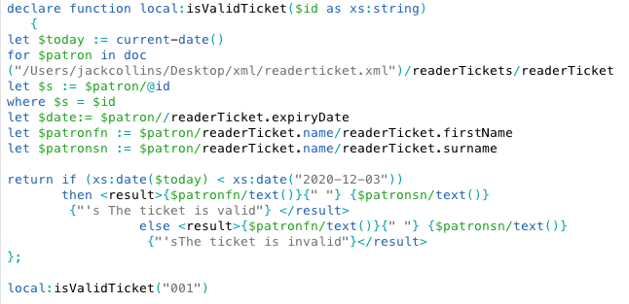

**Query 2: Return a specific type of material that is not available**

**UML Case Supporting**

Request Material

**Description**

This query notifies the patron whether a certain material is unavailable. It checks for the keyword “false” in the *itemAvailable* element in the material class and returns an error message once that keyword is found, otherwise the material is available

**Sample Result**

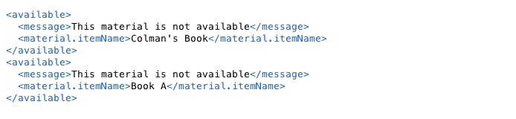

**Code**

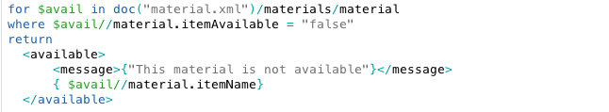

**Query 3:** **Lists all the Librarians and informs the user how long they have been working there**

**UML Case Supporting**

Host Material Consultation

**Description**

This query lists all of the librarians and for how long a certain librarian has been working at the National Library.  We retrieve the ID of a librarian from the librarian xml document.   We then use the built in *currentDate* function and subtract that from the *startDate* of the specific librarian. In order to convert the duration into an integer we divided by P30D, and to get the number of years we divided by 12

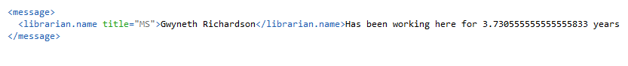**Sample Result**

**Code**



**Query 4:** **Lists all Requested Materials**

**UML Case Supporting**

Update Material Status

**Description**

We compare the *ticketId* and the *patronId* to make sure they are the same. We then return all the materials associated with the *patronID*, this query would be useful to Librarians so they can get an overview of all the requests that have entered the system.

**Sample Result**

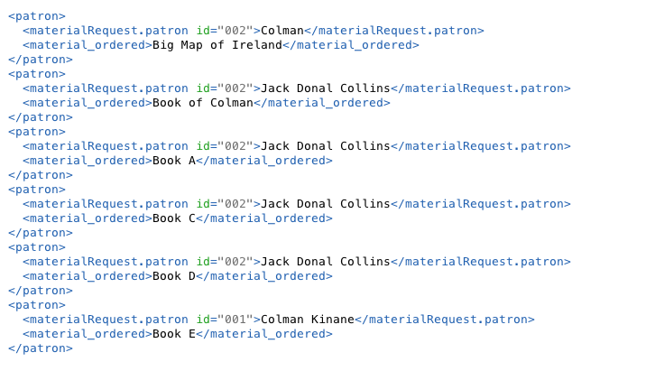

**Code**

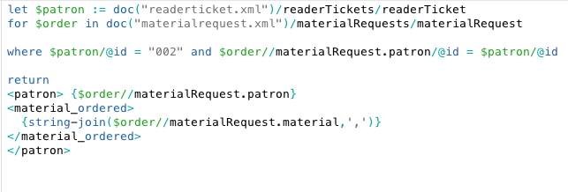

**Query 5: Identified whether a user has requested over the limit (which is 3)**

**UML Case Supporting**

Update Material Status

**Description**

This query notifies the user when they have ordered more materials than given limit. The National Library only permits the patron to request a viewing of 3 materials to view at a time. When the count variable is greater than 3 the query begins to print out an error message

**Sample Result**

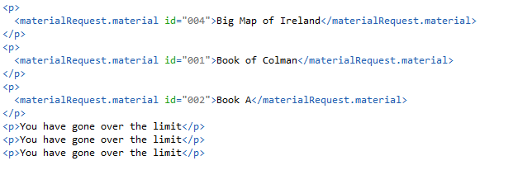

**Code**

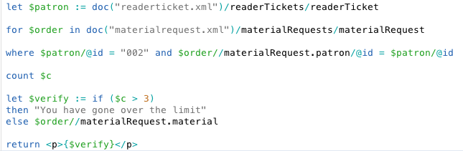

**Query 6: Waitlist Function: takes in the title of a specific material**

**UML Case Supporting**

Update Material

**Description**

This query stores the name of the patron and the date that they wish to view a specific material, so essentially a waiting list. We created a function that takes in a *materialID* and goes through all the material requests to look for patrons that have requested to view that material. It then generates a list of the patrons and orders them according to the date they requested to view the material

**Sample Result**

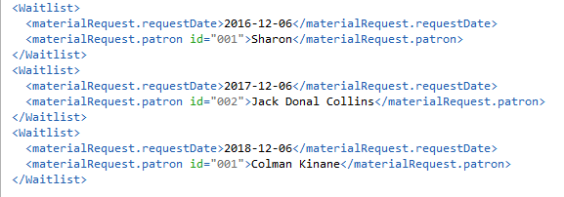

**Code**

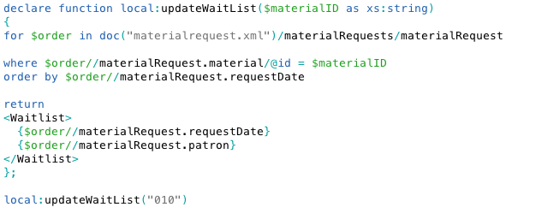

**Query 7: Query for librarian to find out who booked a consultation and why they booked it**

**UML Case Supporting**

Host Consultation

**Description**

This query stores the name of the patron and the date that they wish to view a specific material, so essentially a waiting list. We created a function that takes in a *materialID* and goes through all the material requests to look for patrons that have requested to view that material. It then generates a list of the patrons and orders them according to the date they requested to view the material

**Sample Result**

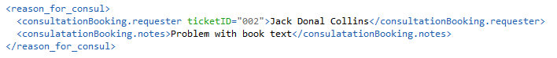

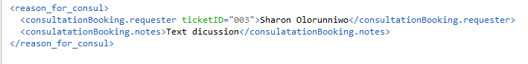

**Code**

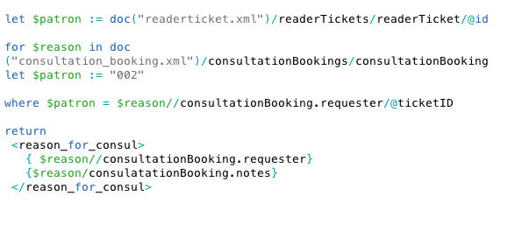

**Query 8: Material List & Source Query**

**UML Case Supporting**

Search Material Database

**Description**

This query searches for a specific type of material and returns the titles of those materials and how they were acquired, The function takes in the *materialType*

**Sample Result**

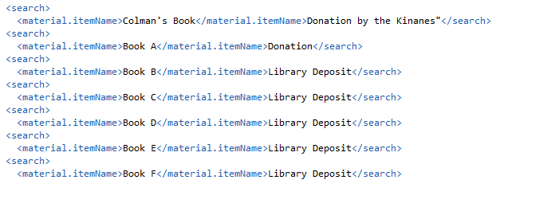

**Code**

